18 September 2020

Lab 2

1. Navigating the file system
   1. $cd /; ls -F;
      1. 
   2. $ cd /etc; ls -F
      1. 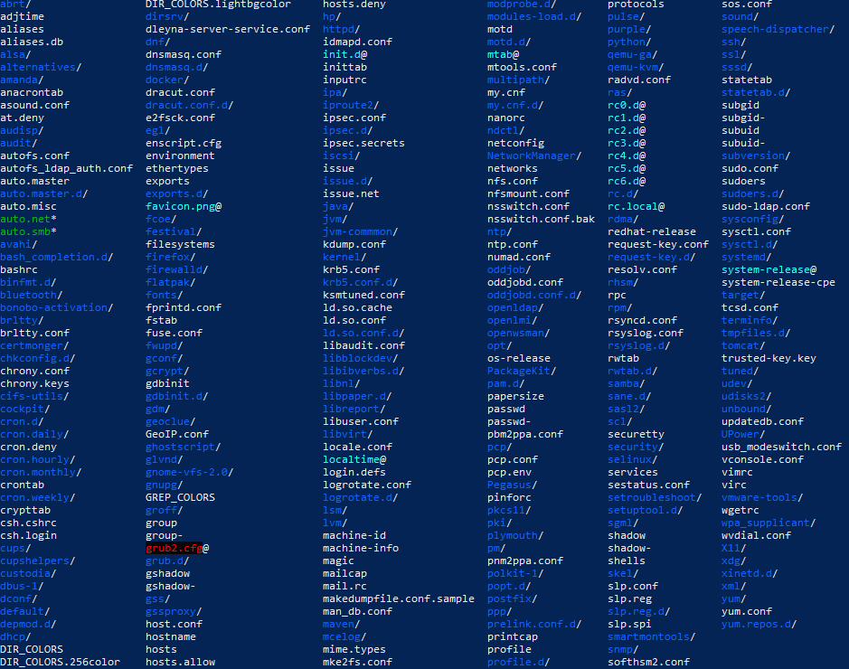
2. $ ls -F | more
   1. 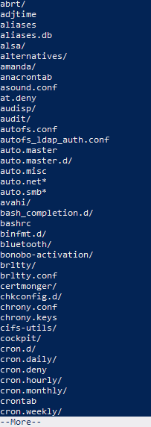
3. $ cd /var/log; ls -a
   1. 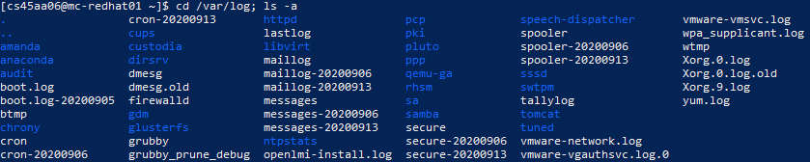
4. $ ls -al
   1. $ ls -al
      1. 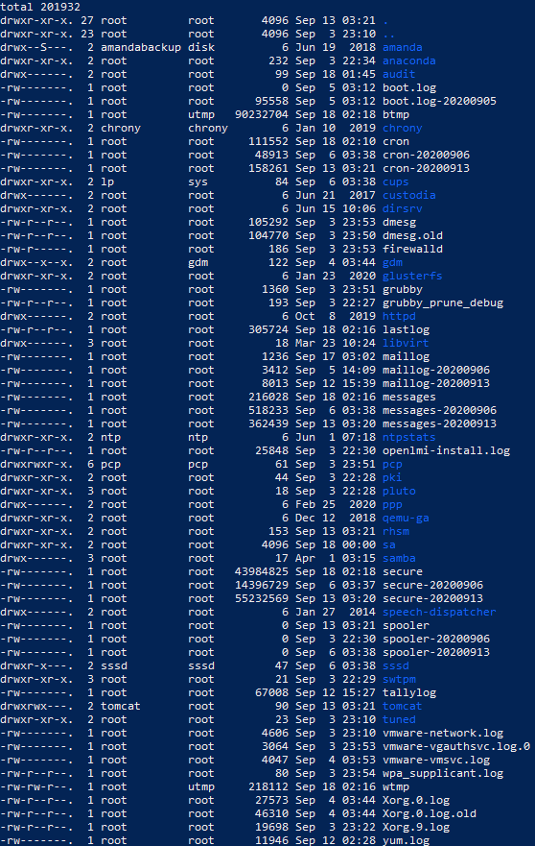
   2. ls -al |more
      1. 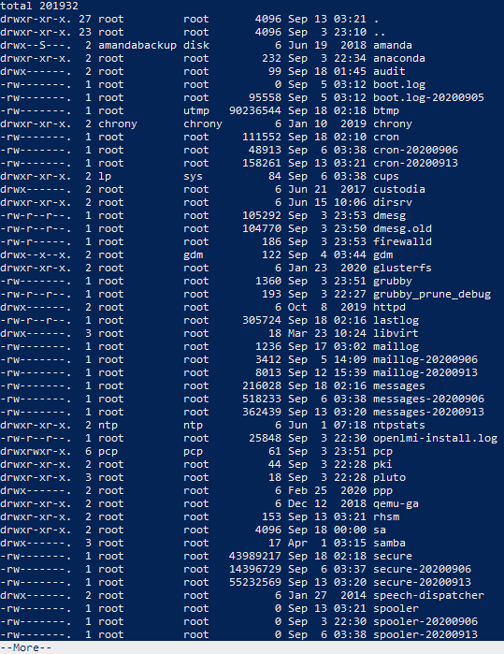
5. $ ls /usr/sbin
   1. $ ls /usr/sbin
      1. 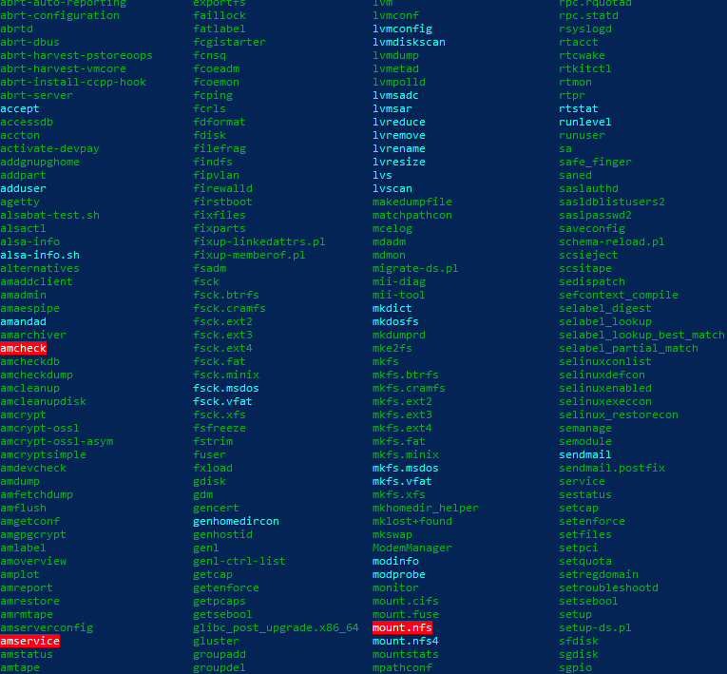
   2. $ ls -F /usr/sbin
      1. 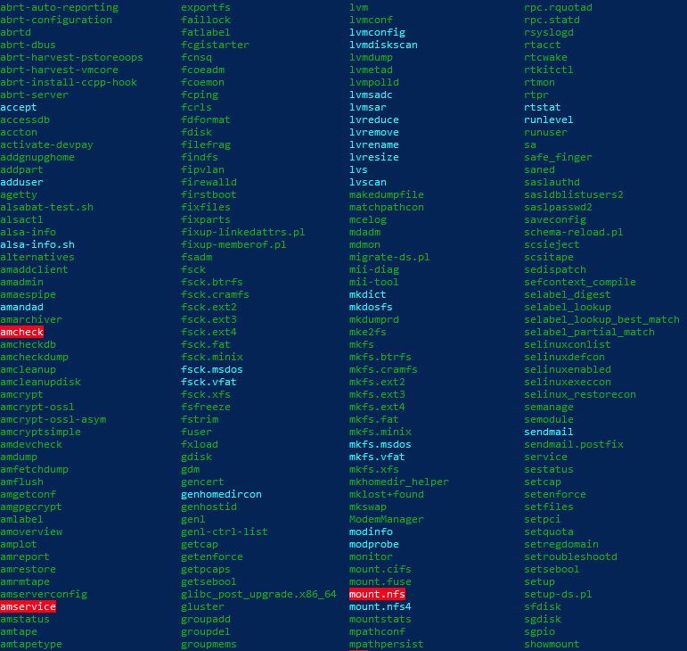
   3. System files
6. $ touch .mydatafile
   1. $ ls -l
      1. No
   2. $ ls -a
      1. Yes
   3. $ ls -al
      1. Me
      2. 0
   4. $ pwd; cal > .mydatafile
      1. $ cat .mydatafile
7. $ cd $HOME; pwd; ls -a
   1. 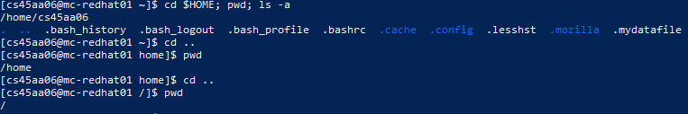
8. $ cd -
   1. 
9. Relative/Absolute
   1. $ cd /home/cs45aa06
      1. $ pwd
         1. /home/cs45aa06
   2. $ cd /var/log
      1. $ pwd
         1. /var/log
   3. $ cd . .
      1. $ pwd
         1. /var
   4. $ cd ~mr-tester
      1. $ pwd
         1. /home/mr-tester
   5. $ cd -
      1. $ pwd
         1. /var
10. $ mkdir $HOME/globbers
    1. $ ls -d $HOME/globbers
       1. /home/cs45aa06/globbers
11. $ touch filex filey filez file55 file60 file70 file100 file200 foo fox
12. ‘f’
    1. $ ls f??
       1. foo fox
    2. $ ls f*x
       1. filex fox
    3. $ ls f*[2]*
       1. file200
    4. $ ls f*2*
       1. file200
    5. $ ls f*[0-9][0-9]
       1. file100 file200 file55 file60 file70
    6. $ ls f*[0-9][0-9]*
       1. file100 file200 file55 file60 file70
    7. $ ls f[!i]*
       1. foo fox
13. $ touch file_one file_two
14. $ ls -a
    1. 
15. $ cat > tester_file
    1. 
16. $ cat tester_file
    1. 
17. $ nano tester_file_2
    1. 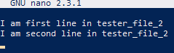
18. $ ​vi tester-v
    1. 
19. $ mkdir /home/cs45aa06/dirx
    1. cd $HOME/dirx
20. dirx
    1. $ pwd
       1. /home/cs45aa06/dirx
    2. $ mkdir ../diry
21. $ mkdir ../../../cs45aa06-tester
22. $ mkdir /tmp/cs45aa06-tester2
23. $ touch /tmp/cs45aa06-tester/data-file
24. $ mkdir /tmp/dirz/dirz
    1. mkdir: cannot create directory ‘/tmp/dirz/dirz’: File exists
25. $ mkdir -p /tmp/dirR/dirS
    1. It works because the directory you’re trying to create doesn’t already exist
26. $ rm /tmp/cs45aa06-tester
27. $ rm /tmp/cs45aa06-tester2
    1. rm: cannot remove ‘/tmp/cs45aa06-tester2’: Is a directory
28. $ rm -r /tmp/cs45aa06-tester2
    1. $ ls /tmp/cs45aa06-tester2
       1. ls: cannot access /tmp/cs45aa06-tester2: No such file or directory
29. $ touch Afile Bfile Cfile
    1. $ ls
       1. Afile Bfile Cfile
    2. $ rm Afile
    3. $ ls
       1. Bfile Cfile
    4. $ rm Bfile
    5. $ ls
       1. Cfile